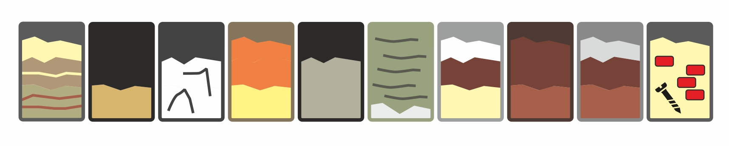

**Soil Classification and Education: The role of soils on urban stormwater management**

**Date: Pécs, November 10, 2022**

**Time 11:30**

**Venue: Testvérvárosok Terei Elementary School Pécs**

**Dissemination and Educational Conference**

The conference is under the patronage of the System Erasmus Project

Share Your Soils 2019-1-PL01-KA203-065101



**Conference programme**

**Thursday, November 10, 2022,**

**11:30 – 11:35 –** Opening ceremony, welcome lunch (sandwiches)

**11:35 – 12:15 –** Introduction of the System project. The SYStem soil application and soil database and their development.

**12:15 – 12:45 –** WRB, Soil Taxonomy or national classification? Which is the Lingua Franca of Pedology?An introduction to soil classification

**12:45 – 13:15 –** Urban soils, Anthroposols and Technosols in Pécs: Their influence on stormwater runoff in Pécs. Sustainable stormwater management in Pécs supported by a hydrometeorological monitoring network**.**

**13:15 – 13:45 –** A simplified guideline to WRB soil classification for general education on soils.

**13:45 – 14:00 –** *Coffee break*

**14:00 – 14:00 –** Adaptation techniques to climate change:Sustainable land use management: The influence of land use types on soil moisture dynamics and runoff properties of loamy soils formed on loess as parent material.

**14:30 – 15:00 –** The Soil Omnibus of the SYStem project. A general overview.

**15:00 – 15:20 –** Which is the ideal soil composition for adequate stormwater management? The sponge city project in Pécs. Results of a rain garden experiment.

**15:20 – 15:40 –** Partitioning of rainwater into runoff and subsurface storage. Influence of soil texture and soil depth on flash flood vulnerability of Pécs.

**15:40 – 16:45/Sunset –** Classification of Technosols and Anthroposols according to the WRB around the Testvérvárosok Terei Elementary School. SYStem soil application in the field.

